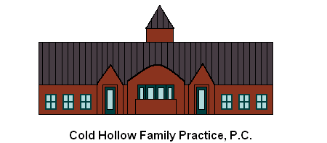
Sliding Fee Schedule Discount Application
Cold Hollow Family Practice, P.C. is committed to providing essential services in our clinic regardless of your ability to pay. We offer discounts based on your family size and annual income.
We invite you to complete the form below so we can determine the level of your discount. The discount will apply only to services received at this clinic, but not services or equipment purchased from another provider, including our outside reference lab, medications, x-ray and other diagnostics and other doctors and providers. There are pharmaceutical programs and hospitals offer discounts, and we can provide information about how to apply for these.
      - Please complete this form every 12 months, or if your family’s financial situation changes. For the purposes of this application, a family is defined as a group of two people or more (one of whom is the householder) related by birth, marriage, or adoption and residing together; all such people (including related subfamily members) are considered as members of one family. Clinic will also accept non-related household members who are dependents when calculating family size.

Patient Name: _________________________________________ Last four digits of SSN: _____________
Mailing Address: ________________________________________________________________________
Date of Application: _________________________ Reviewed by: ________________________________

Please list all family members, including those under age 18:
Relationship | Name | Date of Birth | Social Security Number
Self

Please list the annual income and all sources of income for the whole family:
Source | Self | Others | Total
Gross wages, salaries, tips, commissions, etc.

Income from business and self-employment

Unemployment, workers' compensation, Social Security, Supplemental Security Income, veterans' payments, survivor benefits, pension or retirement income
Interest; dividends; royalties; income from rental properties, estates, and trusts; alimony; child support; assistance from outside the household; and other miscellaneous sources
Total Income per Year

I certify that the family size and income information above is correct:

Patient or Guarantor Name (print): ________________________________________________

____________________________________________________________ Date: __________________
Signature
Office Use Only
Patient Account Number(s) | Approved Discount:
Approved by: | Date Approved:

Verification and Set Up Check List
Identification/Address | Source / Completed by | Date
Identification/Address: Driver’s license, utility bill, employment ID, or other
Income: Prior year tax return, three most recent pay stubs, or other
Decision Letter Sent

Patient Account Set up in Practice Management system

